From 1st week to 1st of November here is my proggress..

Created 4 Html files named as Home,About,Projects and contacts.

* 2nd November

Added my snapchat bit Moji as my avatar in the home page. Also added pulse animations to both avatar and send button in contact me page. Here is how I did it.

Made an animation using @keyframe notation and added it to the “.send” and “#avatar” classes respectfully.

Also added text effects on “I am Gayathra Chanith” heading in home page. When hovering over the color of the text turns yellow.

3rdof November

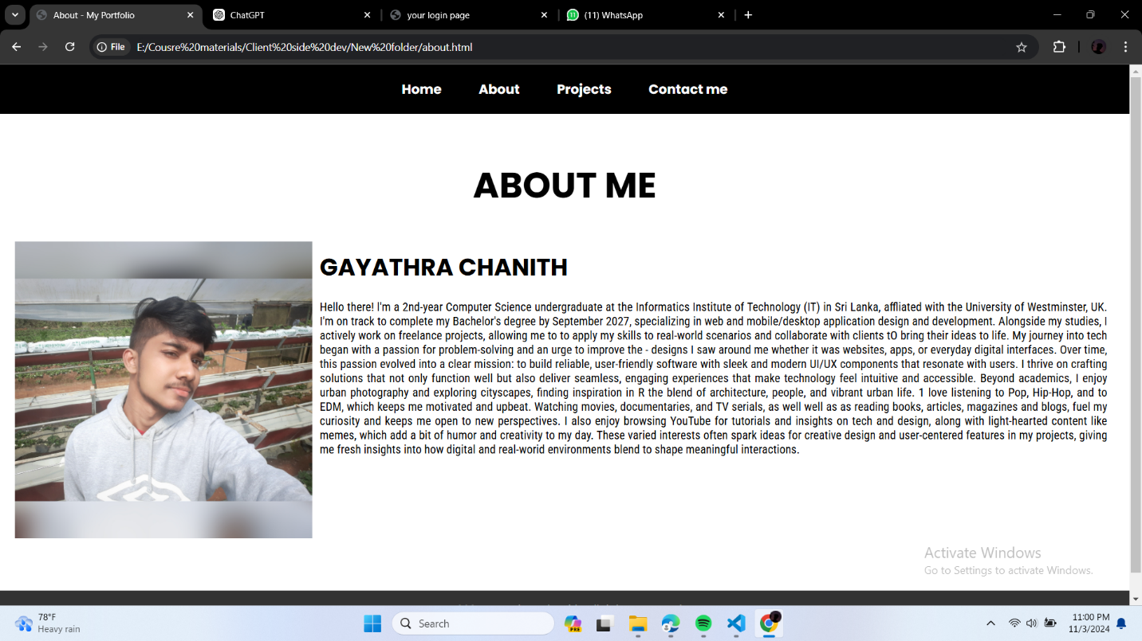Completed about me part.

4th of November.

Completed the task by finally making the website responsive..

Here is the final look.

[My Portfolio_w2051628.docx](https://universityofwestminster-my.sharepoint.com/:w:/g/personal/w2051628_westminster_ac_uk/EYHeSXXRut9MklRbxb9WmHcBAouyntRL5g83xtstTqEDOQ?e=cGKm70)